March 21st - Weekly Update

Front-End Team [ Prasanna and Kavya ]
- Implemented polygon reusability feature allowing users to apply previously drawn polygons across multiple images, enhancing workflow efficiency.
- Implemented polygon reusability feature allowing users to apply previously drawn polygons across multiple images, enhancing workflow efficiency.
- Organized polygons in the tray by grouping them according to their source images, improving navigation and selection.
- Added visual highlighting for selected polygons both on the canvas and in the tray, providing better visual feedback during editing.
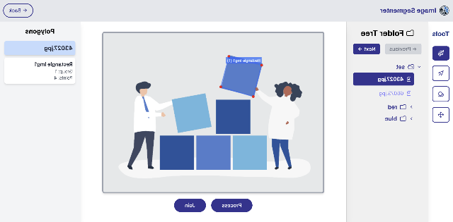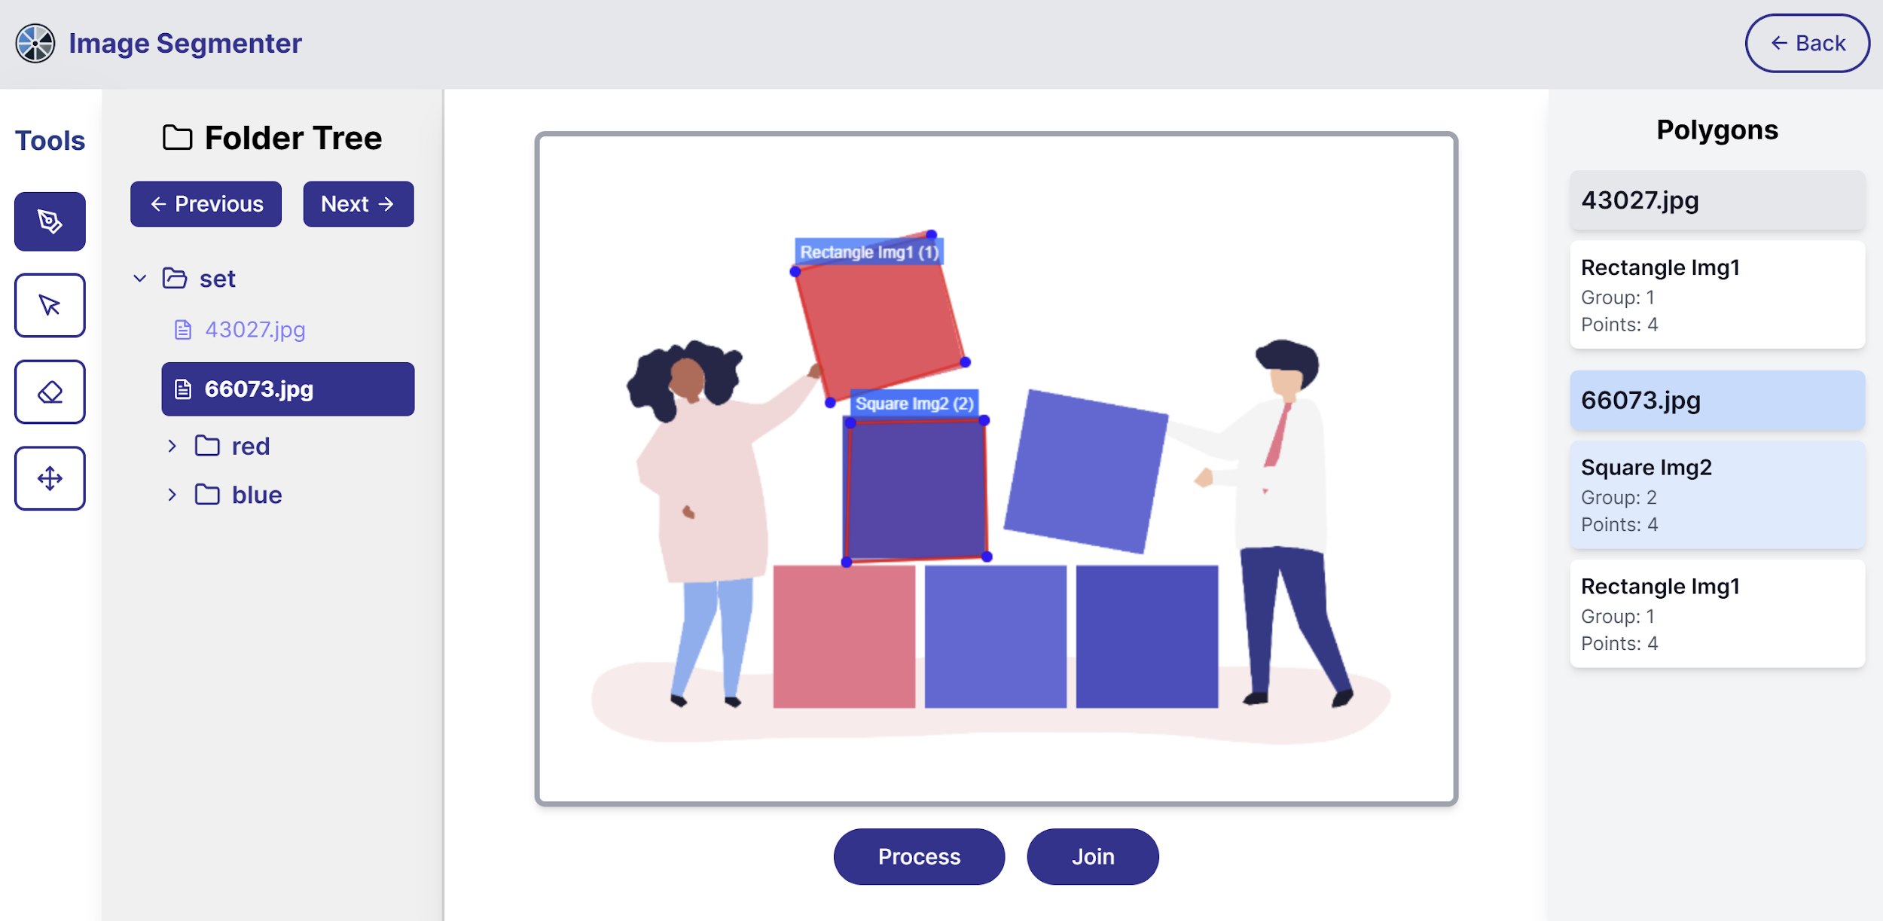

Next Steps
- Implement JSON data export functionality instead of printing polygon coordinates to console, enabling proper data persistence.
- Develop synchronization mechanism for polygons used across multiple images, ensuring that edits made to a polygon in one image are automatically applied to all instances.

Back-End Team [ Aravinthakshan and Janak]
- Terminal working for xmem++ has been done, propagation seems to work well ( attached examples )
- GUI there are still a couple issues ( cuda incompatibility ) but we do not plan on using this

Next Steps
- Work on API to call the endpoints propagate, segment, delete and correct for xmem++

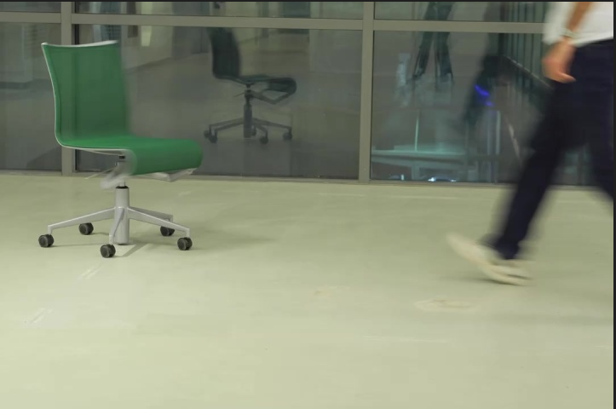
- Test working on multi class segmentation

